**Name: _______________________________________ Partner: ________________________________**

**Python Activity 11: Predefined/Built-in Functions**

|  |
| --- |
| **Learning Objectives**  Students will be able to:  *Content:*   * Explain the purpose of a predefined/built-in function * Explain the functions: abs(), pow(), int() round(), random * Explain the math library functions: floor() and ceil() * Explain the use of the **import**  statement * Explain the purpose of a function argument   *Process:*   * Write code that uses predefined functions   **Prior Knowledge**   * Python concepts from Activities 1-10 |

|  |
| --- |
| **FYI: Predefined/built-in functions:** segments of code already included in Python.*print(), round(), abs(), pow(), int()* are ***examples*.**  **Arguments:** The information that a function needs to work. Arguments are sent to the function between the parentheses ().  To use a function, **call** the function. **input(“Enter your name”)** is a call to the ***input*** function sending the string “Enter your name” as an argument. |

**Critical Thinking Questions:**

1. Circle calls to predefined functions in the following program.

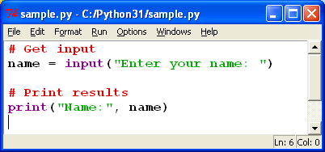

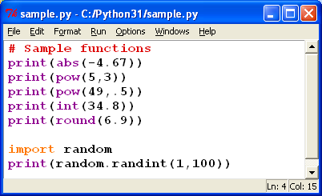2. Enter and execute the Python program on the right.

a. What is the output for each statement ?

* print(abs(-4.67)) ___4.67______
* print(pow(5,3)) ____125______
* print(pow(49,.5)) ___7.0_____
* print(int(34.8)) ____34____
* print(round(6.9)) ____7______
* import random

print(random.randint(1,100)) ___74______

b. What is the difference between the round() function and the int() function?

_______________ ”round()” rounds to the nearest integer based off of the decimal inside; while “int()” just prints the integer before the decimal regardless of the number as a decimal.

3. Each of the following function calls return a value. What is the value returned for each line of code? Verify your answers by executing the code.

a. abs(4.5) __4.5_______ b. int(“678”) __678_

c. round(-5.6) ____-6______

d. import random

random.randint(4,10) _______I got 5, but it does random. __

What is the purpose of “import random”? What happens if you omit that line of code?

___import random allows the list “(4,10)” to have an integer that is randomly selected within that range. Without import, random cannot be defined. _____

______________________________________________________________________________

4. Circle the **argument** in the call to the built-in function:

number = 45.78

answer = round(number)

5. **answer = pow(4,3)**. What is/are the argument(s) in this code? ___4 and 3 ____

6. If a function contains more than one argument, do you think the order of the arguments makes a difference? Explain your answer with an example.

______________________________________________________________________________

______________________________________________________________________________

______________________________________________________________________________

7. Execute the following lines of code:

import math

x = 4.7

y = 5.3

z = -4.8

a = -3.2

print(math.ceil(x))

print(math.ceil(y))

print(math.ceil(z))

print(math.ceil(a))

print(math.floor(x))

print(math.floor(y))

print(math.floor(z))

print(math.floor(a))

1. Explain the purpose of the **ceil()** function. ____”ceil()” is used to return the smallest integer value which is greater than or equal to the specified expression or an individual number.
2. Explain the purpose of the **floor()** function. The “floor()” function is used to return the closest integer value which is less than or equal to the given numeric value

c. Why are the calls to the **floor()**  and **ceil()** functions preceded by “**math.”?**

_____Math is a module that is being called for the specific function (x,z,y,etc) and comes before both “ceill() and floor()” as those both format that module. ____

8. Enter and execute the following code:

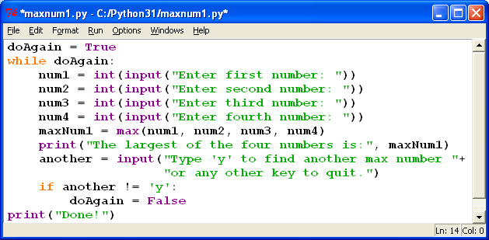

a. What type of variable is ‘doAgain’? __Boolean variable___

b. What does the program do? ______It gives you the biggest number you enter for all four variables. ________

c. What does the following line of code do?

**maxNum1 = max(num1, num2, num3, num4)**

_______Gives the variable “maxNum1” the largest integer in the list in “()”______

d. Experiment with the arguments in the **max()** function in the program to determine if the function must have four arguments. Provide an example for your answer.

________________________________________________________________________

________________________________________________________________________

e. What does the following code in the last two lines of the program do?

if another != 'y':

doAgain = False

___This says if the input is not “y” it makes the value of the variable “doAgain” Fales; breaking the loop and printing “Done” that is outside the while loop.___

**Application Questions: Use the Python Interpreter to check your work**

1. Write a line of code that prints the integer portion of the number 21.45.

______________________________________________________________________________

2. Write code that prompts the user for a floating point number and prints the smallest integer that is larger than the number the user entered.

______________________________________________________________________________

______________________________________________________________________________

3. Write the code to print a random number between one and six.

______________________________________________________________________________

______________________________________________________________________________

4. Assume that a user enters any number and that the number is stored in the variable **userNumber**.

Write a line of code that converts the input to an integer. Then write a line of code that prints the positive value of the user’s input.

______________________________________________________________________________

______________________________________________________________________________

5. Write a line of code that calculates the square root of 900 and stores the result in the variable **answer.**

______________________________________________________________________________